Step-by-Step Debugging In ADL Service And User Process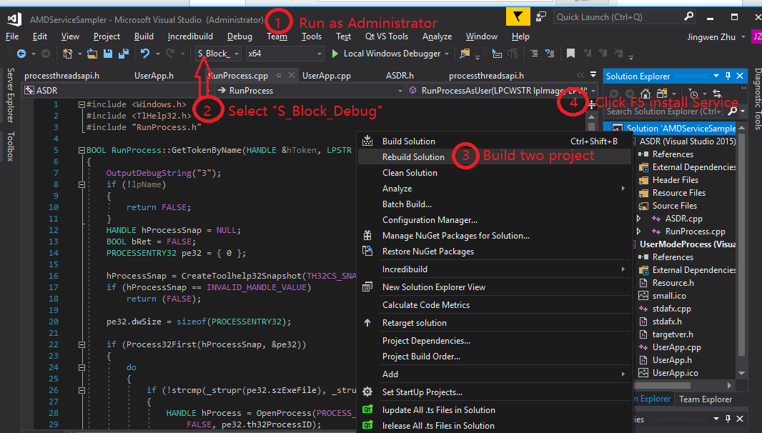 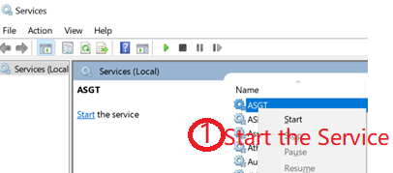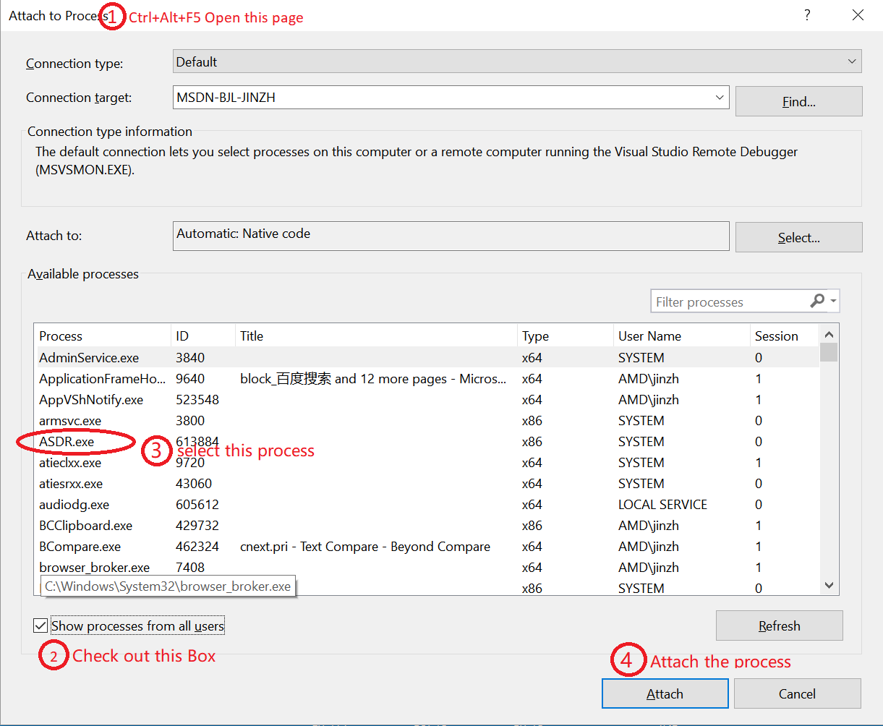
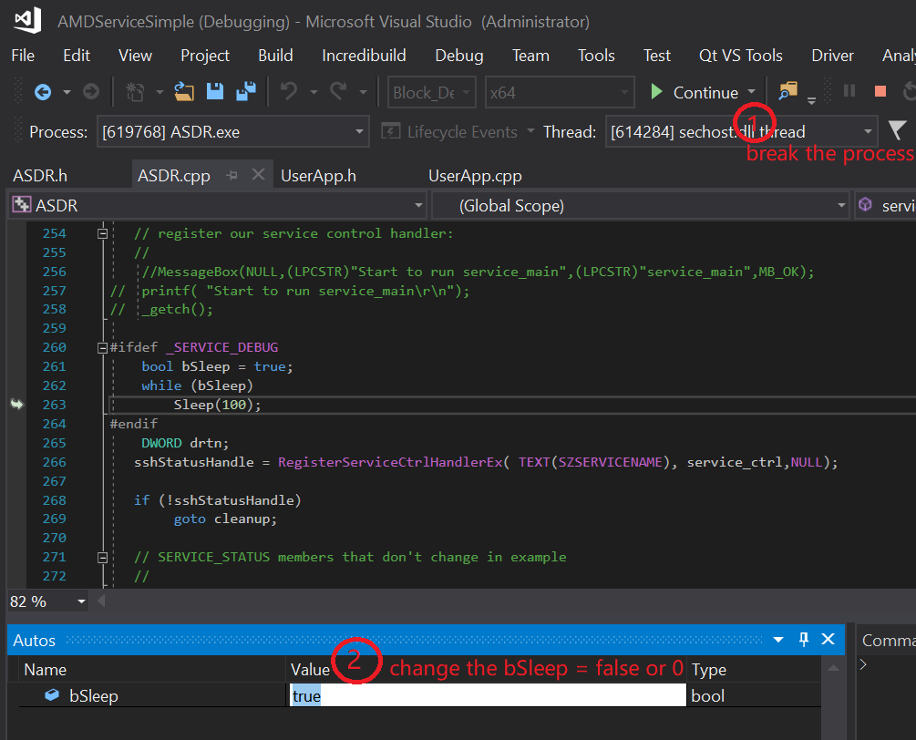
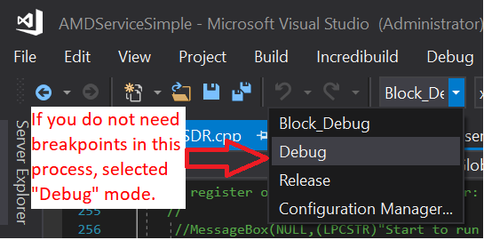
Similar debugging steps are in the user mode program. (Build with U_Block_Debug , running service and attach the UserModeProcess.exe)

- You as a developer simply need to follow the TODO's outlined in files

- You can delete Service like change Service path using Administrator run cmd.exe : sc delete ASGT
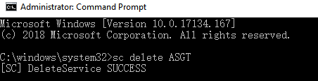
- Compare with service and user mode process run ADL, please select “Service_ADL_debug”
